**­**

**STUDENT FEEDBACK SYSTEM**

**An Intelligent Powerful System for feedback and analysis**

Software Requirement Specification

**Submitted to:**

Mr. Anil Chaudhary

(Professor & HOD, IT Dept.)

**Submitted By:**

DEHUL PARASHAR- 16ESKCS711

Contact: [dehulcse@gmail.com](mailto:dehulcse@gmail.com) +91-8426813361

**TABLE OF CONTENTS:**

**1. Introduction**

1.1 Overview……………………………………………………………………………... 3

1.2 Why is there a need for it……………………………………………………............ 3

1.3 How SFS can help?....................................................................................................... 4

1.4 Scope……………………………………………………………………………......... 4

1.5 Definitions, Acronyms and Abbreviations…………………….…………………....... 5

* 1. References …………………………………………………………………………… 5

1.7 Technologies to be used ……………………………………………………………... 5

**2.Working**

2.1 Student-side…………………………………………………………… 6

2.2 Admin-side……………………………………………………………………… 13

**3. Overall Description**

2.1 Use-Case Model Survey…………………………...……………………...… 16

2.2 ER Diagram…………………………………………………………………. 18

2.3 Data Dictionary…………………………………...…………………………. 19

2.4 Assumptions and Dependencies……………………………………………... 20

**4. Specific Requirement**

3.1 Activity Diagrams…………………………………………………………... 21

3.2 Sequence Diagrams………………………………………………………...... 23

3.3 Supplementary Requirements……………………………………………...… 25

3.4 System Requirements……………………………………………………………………….. 25

**1. Introduction:**

**1.1Overview:**

This Student Feedback system is designed to work as an asset for an organization like college where a feedback is generated by the students of the college about the faculties who have taught them.

This system allows the clients to provide their feedback and comments through a desktop. The feedbacks are then stored in a database and a series of manipulations are performed over that data, thus providing the college administration the result or the score for each specific faculty under review.

This system will consist of various modules like:

* Entrance Module
* Feedback form Module
* Results module
  1. **Why is there a need for it?**

The general method to obtain a feedback is to provide the client with a pen and paper and asking him to rate the services he/she may have used. This process requires a good amount of paper for the feedback forms. Also, a lot of human efforts are required to manually enter the data from form to an application or software which mines the data from a result. Also, a human might make a mistake to fill wrong data which might prove disastrous for an organization.

This whole process is very time consuming and it also have an overhead of financial investment for the form printing, workers to feed data to a system and maintenance of that system.

Thus, it presents a problem when the number of people to provide the feedback is large.

## How SFS can help?

This system will make the client to provide his/her feedback/comments to a platform available either online or at a Local Area Network. This will end the requirement of papers as the feedback form now can be filled directly through a computer or a mobile, if required. This will also be a significant step to SAVE TREES.

The feedback given by the client will be saved directly to the database Thus, eliminating the need of human efforts to manually enter the data from a paper.

This system can analyze the available data and deriving the results at any instant within seconds when required.

**1.4 Scope:**

* The main users of this system are the college students.
* All students have their own college ID.
* The students will enter their college Id and section before starting the feedback.
* Student’s is free to leave once the form has been submitted.
* No student can view the results for a faculty. Only the authority can view the results.
* The authority can analyze the data even when the feedback process is not fully completed.

**1.3 Definitions, Acronyms and Abbreviations:**

* **SFS –** Student Feedback System

**1.5 References:**

* + - Wikipedia – www.wikipedia.com

**1.6 Technologies to be used:**

## Database Application - MySQL

## Development tool - Rational development tools

**2.Working:**

**Student-side:**

The working of this system can be understood by the following steps:

These steps are designed by taking into consideration the fact that the system is already installed on the Local Area Network and is accessible through an address by all the clients in that network.

**STEP 1:**

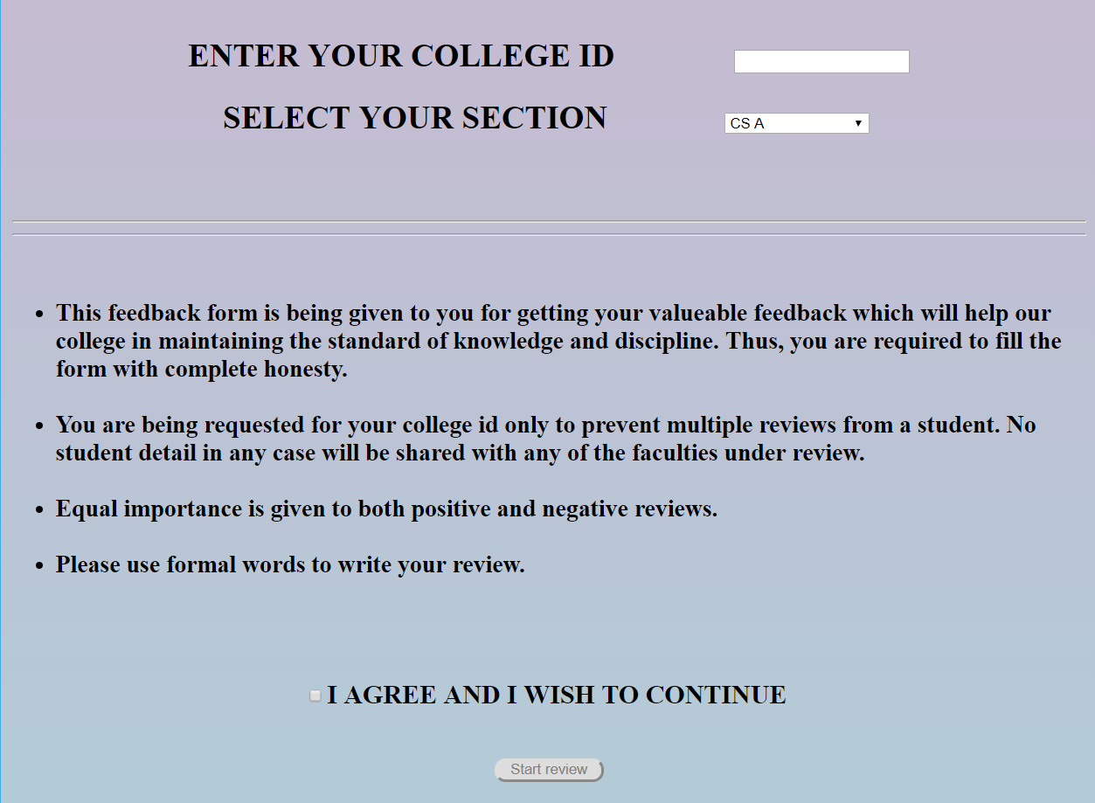

The student accesses the system from the LAN and enters his college ID and selects his/her section from a drop-down list. The college ID will help the system to identify any student who misbehaves (use of inappropriate language) during the feedback.

The student must agree to the terms and condition of the feedback before starting the feedback. The submit button is disabled by default. This means that the student cannot start the feedback before agreeing to the terms and conditions.

Terms and conditions are as follows:

* This feedback form is being given to you for getting your valuable feedback which will help our college in maintaining the standard of knowledge and discipline. Thus, you are required to fill the form with complete honesty.
* You are being requested for your college id only to prevent multiple feedbacks from a student. No student detail in any case will be shared with any of the faculties under review.
* Equal importance is given to both positive and negative feedbacks.
* Please use formal words to write your feedback.

These terms and conditions are shown to user at the time he/she is submitting college id and section. The red arrow in the above image shows the terms and conditions.

The submit button will only be enabled only when student agree to the terms.

**STEP 2**:

After the student submits his/her details, he/she is redirected to the feedback form page.

The feedback form contains two sections:

1. Academics
2. Overall feedback

**Academics:**

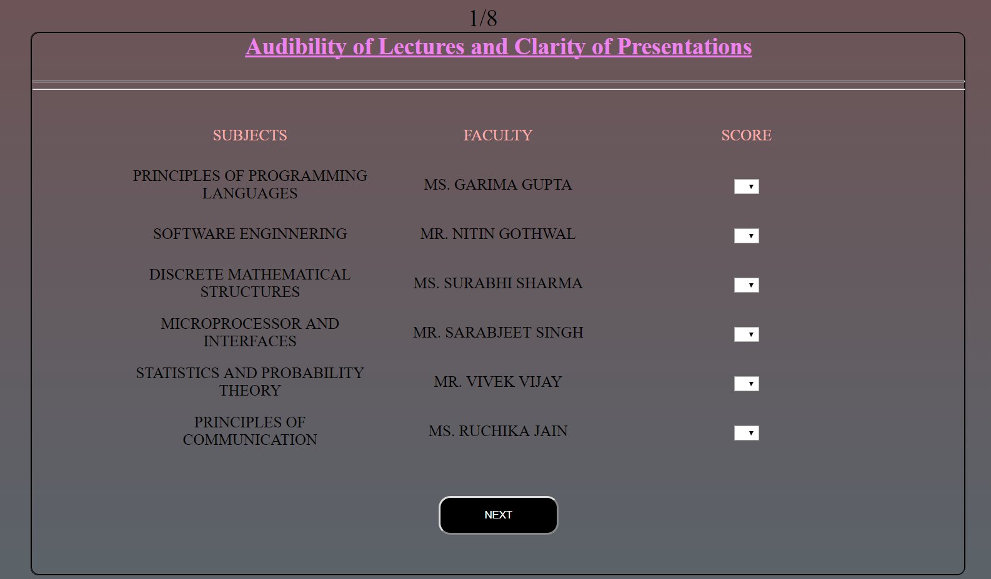

Here, the student is presented with a form with names of faculties who teach him/her corresponding to the subjects.

The students are required to give score to each faculty on a scale of 1-5. **Each and every score field is mandatory to be filled. The form will not be submitted if any field is left empty.**

There are 8 different factors (indicated in the image by the blue marker above) on which a faculty is rated by a student. These are, namely,

1.Audibility of lectures and clarity of presentations.

2.Methodologies and working style with chalk duster, Presentation work.

3.Attitude towards teaching and students.

4.Overall quality of teaching.

5.Emphasis on methodical and systematic working.

6.Availability of instruction sheets/other materials.

7.Feedback on report/sessional work by teacher.

8.Interaction with faculty during session.

The student will provide score to all the faculties for each factor.

Two buttons are provided to the student “PREVIOUS” AND “NEXT” which works as follows.

**PREVIOUS BUTTON:**

This button will allow the student to move to the previous factor score he/she allotted. The student can change the scores of any faculty for any factors any number of times before submitting the final form.

**NEXT BUTTON:**

This button will allow the student to move to the next factor to provide score. If the student hits the next button after reaching the last factor form, the form will automatically scroll down for the further feedbacks.

**Overall feedback:**

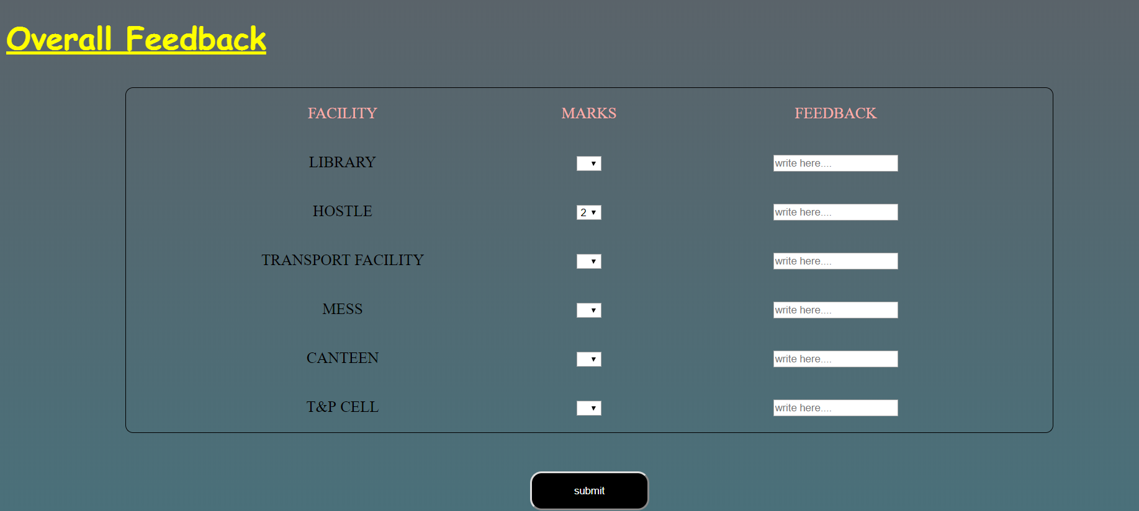

After filling the scores in the academic’s section, the student now comes to complete the overall feedback queries which are related with the following fields:

* Library
* Hostel
* Mess
* Canteen
* Training and Placement cell
* Transport faculty

The student needs to provide a score between a 1-5 for each of the above-mentioned fields.

In this case, the students are also allowed to write a review in their own words describing their views about the place under consideration and suggesting changes that needs to be done to make it provide better services to students.

The maximum length allowed for the text feedback is 50 characters. This field is not mandatory to be filled. It depends on the choice of student whether he/she wants to provide written feedback or not.

**STEP 3:**

After providing score in the academics as well as overall feedback section, the student will submit the form by clicking the submit button present at the bottom of the form.



The red arrow points to the submit button in the image. As discussed, this button is the very bottom of the page.

The score given to each faculty is saved in the faculty’s data table already built in database.

**Admin-side:**

A major functionality of this project is the control it provides to the admin to derive the results from the data stored in database.

This part of the system is only accessible by the admin and no student can access this sub-system.

The admin can derive the results for a faculty in two steps:

**STEP 1: SELECTING FACULTY**

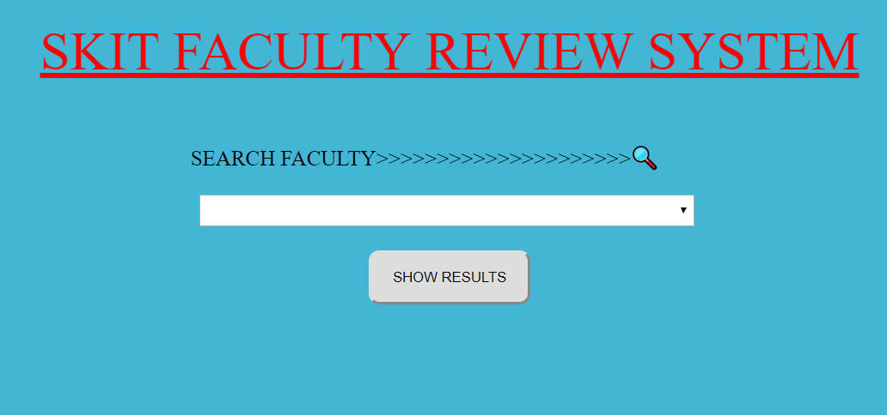

The admin will select the name of the faculty from a drop-down list he/she wants to see result of.

**STEP 2: ANALYZE RESULTS**

The admin then hits the show results button.

The admin is then redirected to a page where he sees the name of faculty, the sections he/she teaches.

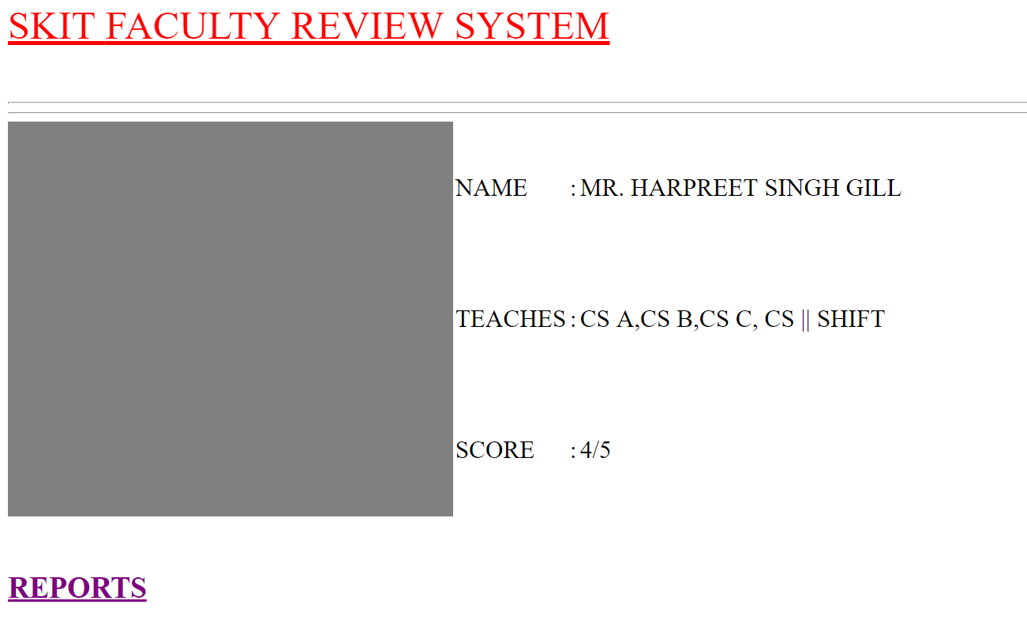

The data set of that faculty is then accessed and results are derived in form of a graph. The graph is plotted using a python script working together with PHP and plotted under reports section of the image shown above.

A sample result graph is shown below.

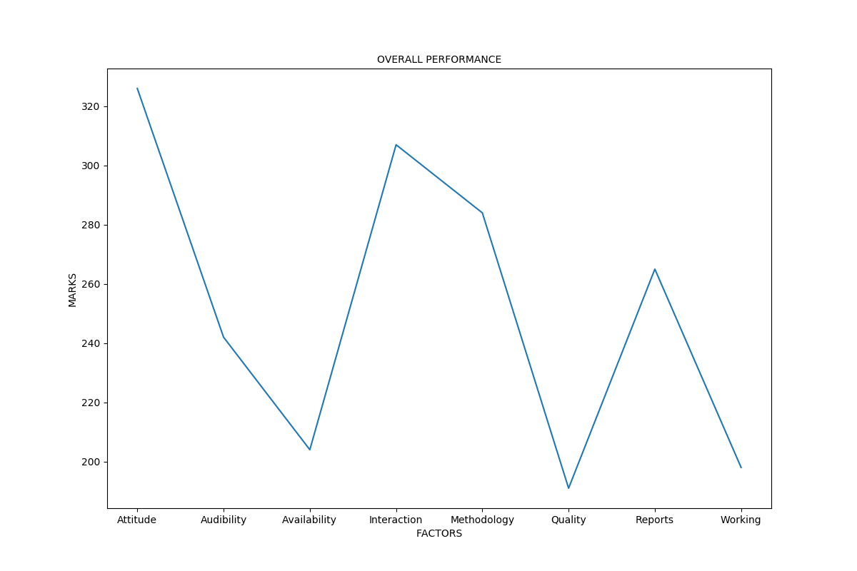

The main advantage of this system for the admin is that he/she, now, does not need to wait for days to derive the results from the data as this system has the capability to do this task within seconds.

**3. Overall Description:**

**2.1 Use - Case Model Survey:**

* **Admin:**

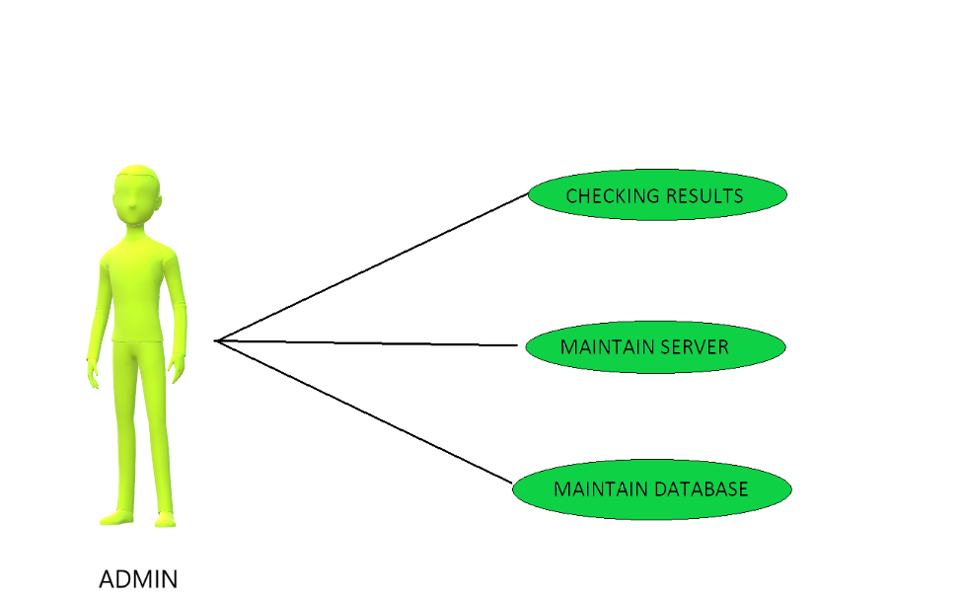

College Authority is responsible for checking out the results time to time and maintenance of the system.

**a. Checking results:** Authority is responsible for checking out the results for each faculty.

**b. Maintain Database:** College authority must keep the feedback data for at least two years. Authority must keep the data safe.

**c. Maintain server:** The server hosting the system must be working at a constant rate without a lag.

* **Student:**

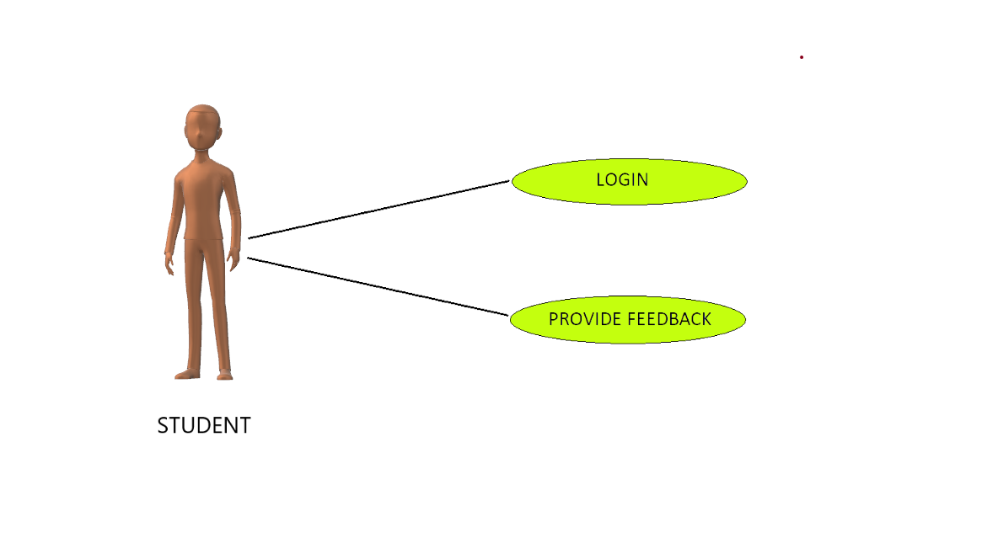

Student is responsible for submitting his feedback which is best true to his/her knowledge. He can do following tasks:

**a. Login:** The student will login by filling out his college ID and his current section.

**b. Provide feedback:** The student will fill out the valuable feedback form honestly. If a student uses inappropriate words, he/she can be tracked down by his/her college ID.

**2.2 ER Diagram:**

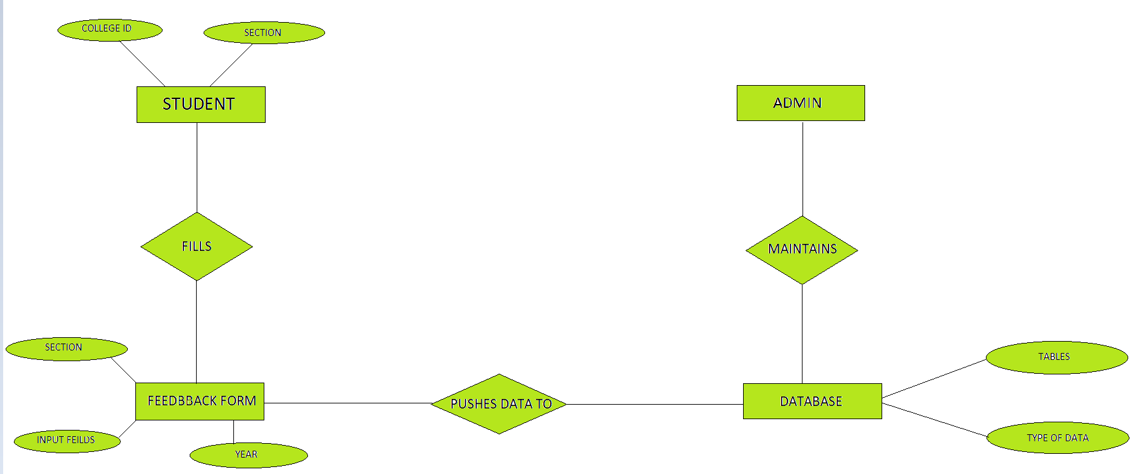

**2.3 Data Dictionary:**

* **STUDENT:**

|  |  |  |  |
| --- | --- | --- | --- |
| KEY | NAME | DATA TYPE | LENGTH |
|  | STUDENT COLLEGE ID | INT | 5 |
|  | STUDENT SECTION | VARCHAR | 20 |

* **FACULTY:**

|  |  |  |  |
| --- | --- | --- | --- |
| KEY | NAME | DATA TYPE | LENGTH |
| Primary Key | FEEDBACK SERIAL NO | INT | 10 |
|  | FACULTY FIRST NAME | VARCHAR | 20 |
|  | FACULTY_LAST_NAME | VARCHAR | 20 |
|  | SECTIONS HE/SHE TEACHES | VARCHAR | 100 |
|  | TOTAL SCORE | INT | 5 |

* **DATABASE TABLES DETAILS:(SAME FOR EVERY FACULTY)**

|  |  |  |  |
| --- | --- | --- | --- |
| KEY | NAME | DATA TYPE | LENGTH |
| Primary Key | SERIAL NO | INT | 10 |
|  | COLLLEGE ID OF STUDENT | INT | 5 |
|  | SECTION OF STUDENT | VARCHAR | 20 |
|  | AUDIBILITY | INT | 1 |
|  | METHODOLOGIES | INT | 1 |
|  | REPORTS | INT | 1 |
|  | ATTITUDE | INT | 1 |
|  | QUALITY OF TEACHING | INT | 1 |
|  | SYSTEMATIC WORKING | INT | 1 |
|  | AVAILABILITY OF MATERIALS | INT | 1 |
|  | INTERACTION WITH STUDENTS | INT | 1 |

**2.4 Assumptions and Dependencies:**

* The database is created prior to the installation of the system.
* The database must be named FRS.
* Tables with faculty names in lower case must be created at the time of database creation.

**4. Specific Requirement:**

**3.1 Activity Diagram:**

* **STUDENT**

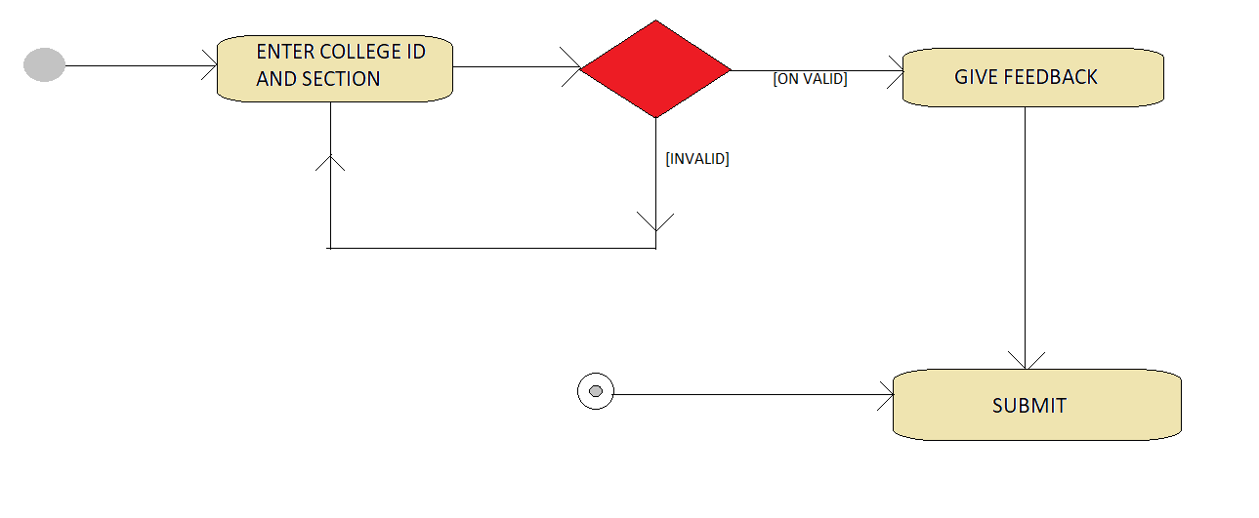

Firstly, student will enter the system by entering college ID and section. If the details are valid then, he/she will be able to provide feedback. But if the password is invalid then, the student will have to re-enter the details.

Once the student makes successful entrance, he/she can provide feedback. After successfully filling up the form and submitting, student will be free to leave the system.

* **AUTHORITY**

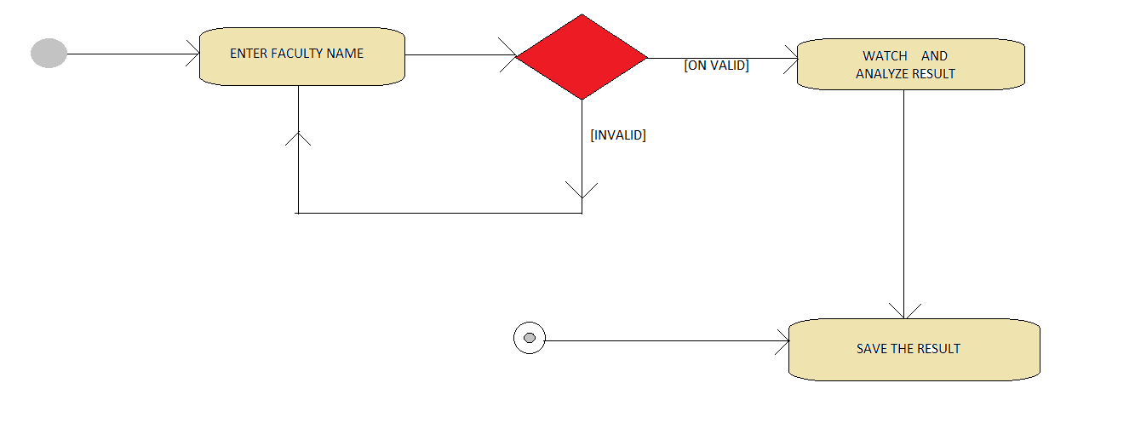

The authority does not need any user id and password to see the results. They have direct access to their respective portals where they can search the faculty by names and get their results.

**3.2 Sequence Diagram:**

* **STUDENT**

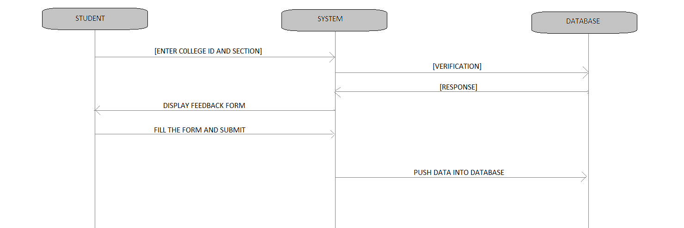

In the beginning, the student enters into the system with the verification of his/her college ID password. After the entrance, the student will be presented with the feedback form which the student required to fill.

When the student has filled up the form, the student requests for submission. The system then pushes the form data into database.

* **AUTHORITY**

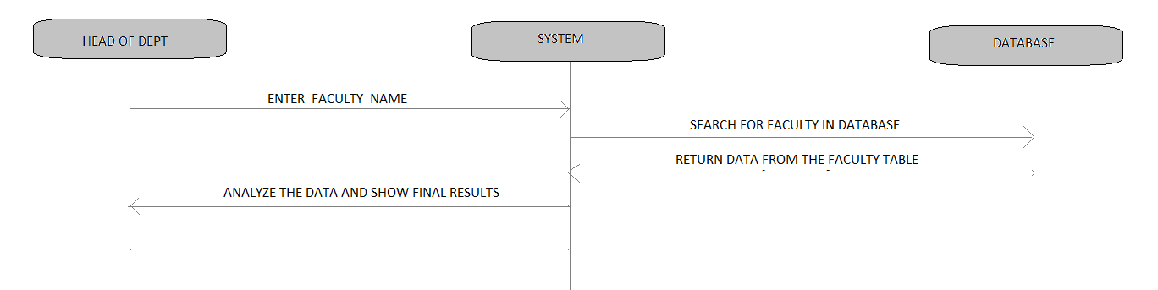

At the authority side, when any head of department or any other person in authority searches for a faculty, the respective faculty’s data is accessed from the database and the required analysis is performed over that data.

The results are then presented in form of graphs which can be saved for future reference.

**3.4 Supplementary Requirements:**

* The student providing the feedback must belong to the college and must have a college id and section.
* Students must be given proper time to completely fill up the feedback form.

**3.5 System Requirements:**

* Browser: Google Chrome
* Operating system: Windows 7/8/10, Linux

--------------------------------------------------------------------------------------------------------------------------------------------------------------------------------------------------------------------------------------------------------------------------------------------------------------------------------------------------------------------------------------------------------------------------------------------------------------------------------------------------------